# Water Cycle

|  |  |
| --- | --- |
| Name: |  |
| Class: |  |
| Period: |  |
| Date: |  |

Carefully read each question and then circle the letter of the correct answer.

1. Recall the main source of heat energy needed to power the water cycle by evaporating water.
   1. Burning fossil fuels
   2. Natural hot springs
   3. The Sun
   4. Forest fires
2. The Sun heats water stored in oceans and lakes which causes it to evaporate. State whether this process produces steam or water vapour?
   1. Water vapour
   2. Neither
   3. Steam
3. Name the state of water vapour.
   1. Gas
   2. Liquid
   3. Solid
4. Recall what is formed when water vapour condenses.
   1. Clouds
   2. Oceans
   3. Steam
5. Name the pocess that causes erosion.
   1. Runoff
   2. Infiltration
   3. Filtration
   4. Transpiration
6. Name the process of water being absorbed by the ground.
   1. Precipitation
   2. Infiltration
   3. Runoff
   4. Evaporation
7. Name the process of gaseous water cooling to form a liquid.
   1. Transpiration
   2. Evaporation
   3. Precipitation
   4. Condensation
8. Name the process involves water falling from clouds to the Earth in either solid or liquid form.
   1. Precipitation
   2. Condensation
   3. Transpiration
   4. Evaporation
9. 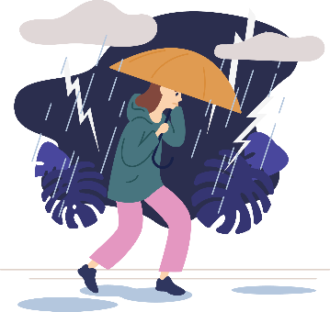State which of the following options is NOT a way in which humans influence the water cycle?
   1. Burning fossil fuels
   2. Deforestation
   3. Tracking the weather systems
   4. Pollution
10. 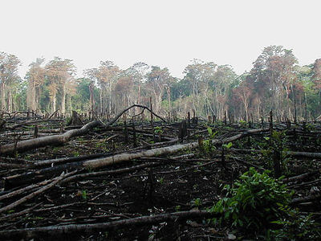Recall what deforestation can lead to.
    1. Decreased humidity
    2. High water leveles in dams
    3. Increased rain
    4. Increased humidity
11. State what decreased humidity can lead to.
    1. Increased atmospheric water vapour
    2. Increased water stored in dams
    3. Decreased rainfall
    4. Increased rainfall
12. Clarify how pollution is affecting our usable freshwater supply.
    1. It is not affecting freshwater, only saltwater
    2. Not changing it, as more freshwater is being formed in the atmosphere
    3. It is decreasing the freshwater supply.

Select the correct words to fill in the spaces below.

**loses evaporates condenses ocean gains**

Water in the ______________ is heated by the sun. It ___________ and forms water vapour.

Clouds form when water vapour condenses. This happens because the water vapour _____________ heat energy as it rises.

**quickly evaporate puddle ocean rain**

When water precipitates as _____________ it either soaks into the ground or falls into a lake, river or ocean. If it falls into an ____________ it could take a very long time to ____________, but it falls into a ____________ it could evaporate very _____________.

**infiltration flows runoff**

_______________ occurs when waater is absorbed by the soil.

_______________ occurs when water ______________ across the ground into a lake, river or ocean.

**Flowers steam water vapour transpiration roots infiltration leaves**

Water is returned to the water cycle after it is absorbed by soil into the ______________ of a plant, it then travels through the plant and escapes through the ______________ of the plant as _____________.

This is called ______________.

Short Answer

1. Imagine you are living on top of a mountain. As the season changes from winter to spring the snow around your hut begins to melt.

Interpret what is happening to the snow and propose the possible processes the water could go through before it reaches the Earth again.

*Include the keywords evaporation, precipitation, condensation and absorbed in your answer.*

1. Imagine you live in a large city. Most of the land is covered by cement, tarmac or buildings. When it rains all the water that builds up in the gutters is transported by pipes to a nearby river. On the outskirts of the city there are several factories that burn fossil fuels.

Extrapolate how the aspects of the city described above interrupt the water cycle. *Include the following keywords in your answer: evaporate, water vapour, flood, infiltrate and acid.*